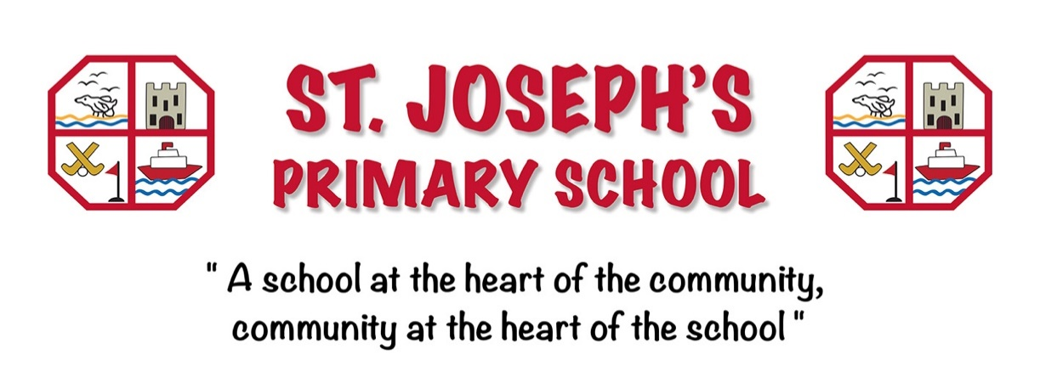

PTFA Code of Conduct
Introduction
This Code of Conduct applies to all committee and non-committee members of St Joseph’s Primary school. It outlines our shared commitment to professional and ethical behaviour and complements the PTFA's legally-binding constitution.
To ensure the success and integrity of the PTFA, all members are expected to adhere to these guidelines during any activity carried out on its behalf.

Code of behaviour
· Membership: Any parent or guardian of a pupil at St Joseph’s Primary school, as well as all school staff, are considered PTFA members with a vested interest in enhancing pupils’ school experience
· Voluntary service: Participation is voluntary and must not be pursued for personal gain
· Best interests: Members must act in the best interests of the PTFA and the school
· Constructive participation: Positive and relevant contributions to meetings are encouraged
· Respect & inclusivity: All members have the right to be heard and must respect differing opinions
· Responsible communication: Members should communicate respectfully. The committee have created a dedicated PTFA WhatsApp group, this will be reviewed annually at the start of each new academic year to add new members or create a new group, if necessary. The PTFA also have an email address for contact – stjosephsps.pfta@yahoo.com School-related matters should be directed to the school office
· Social media: Members will be respectful of each other, the association and the school when using social media. Grievances between the committee, association and school should be discussed with the Chair of the PTFA or the Principal - Laura Fitzsimons rather than through social media platforms
· Response times: Emails to the PTFA may not receive immediate replies. Committee members volunteer in their free time. All queries will be discussed by the committee and may be added to the next meeting agenda
· Decision-making: The committee operates according to the PTFA’s constitution. Decisions are made by consultation with the majority the committee members. Consultation with the wider membership may occur, but the committee’s decision is final
· Confidentiality: Matters of a confidential nature (especially those involving individuals) must be discussed only within closed committee meetings. Confidential details will be redacted from minutes when necessary
· Conflict of interest: Any member with a conflict of interest must declare it and step back from related discussions
· Respect for property: Members are expected to treat school property and one another’s belongings with respect
· PTFA assets: All documents and items related to PTFA work are PTFA property. Upon leaving, members must return all relevant materials to the committee
· Breach of conduct: If a member’s behaviour violates this code or harms the reputation of the PTFA or St Joseph’s primary school, the committee reserves the right to remove that member from future involvement.

Policy review
This policy will be reviewed annually by the Chair of the PTFA and Principal Laura Fitzsimons to ensure it continues to support both the organisation and its volunteers effectively.

Signatures
Approved and adopted by the committee of St Joseph’s Primary School PTFA

Name: ____________________________________

Signature: ____________________________________

Date: ____________________________________

