Safe Route to School 2019-2020

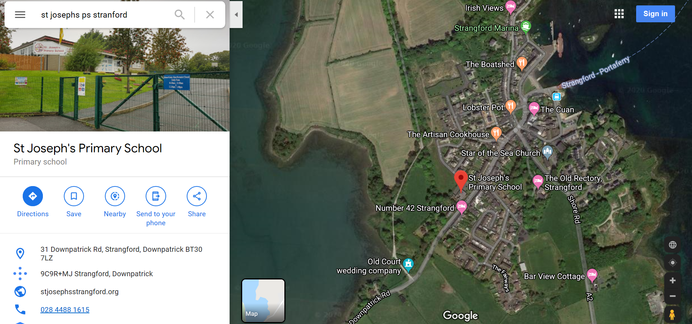

Tips when travelling to and from school

If you live in Strangford village, use the map to locate where your house is. Discuss with your parents how you can travel safely to and from school.
Here are a few tips to help you:
- Always walk on a footpath.
- When crossing the road, use the ‘Green Cross Code’ – Stop, Look and Listen!
- If scooting or cycling, always wear the appropriate clothes and safety gear eg helmet and high vis vest in the dark winter months.
- You can also ‘Park and Stride’. Park your car at The Artisan and travel to school actively. You do not have to cross any roads for this.

